**Kelompok A05**

Topik: SIASISTEN

Alamat repository online: <https://github.com/idiotme/tadsab.git>

# \i D:/KULIAH/V/Basdat/tadsab/CreateTable.sql

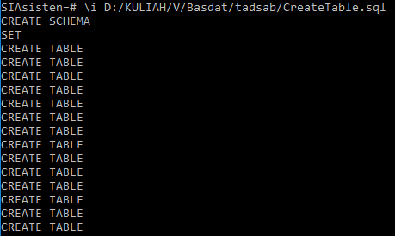

# \d

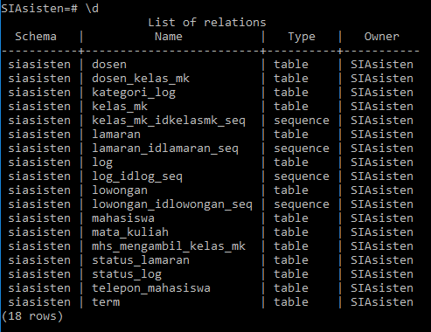

# \d MATA_KULIAH

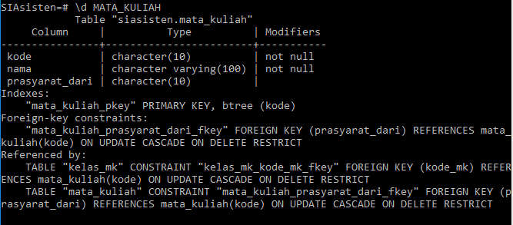

# \d TERM

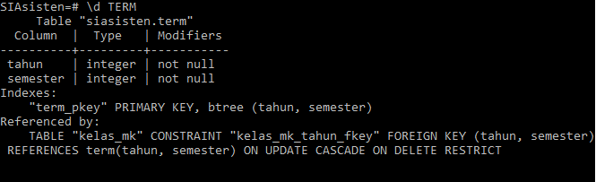

# \d KELAS_MK

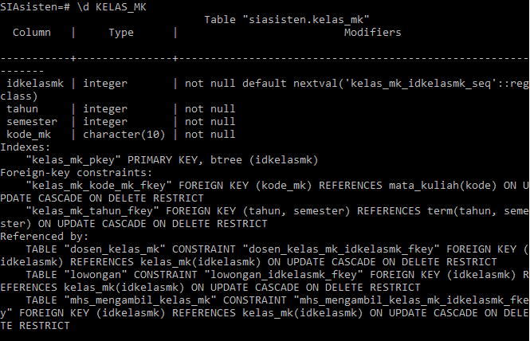

# \d DOSEN

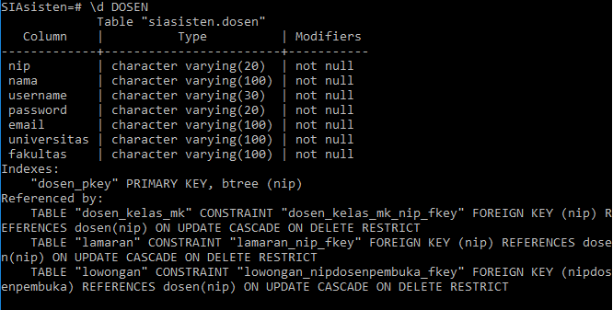

# \d MAHASISWA

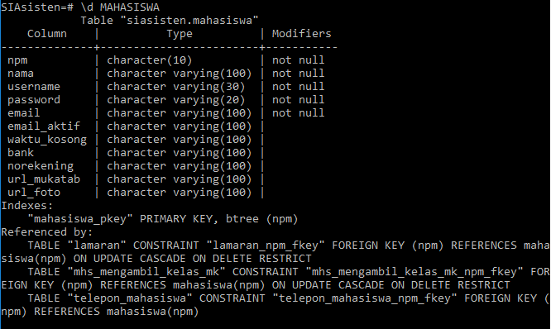

# \d TELEPON_MAHASISWA

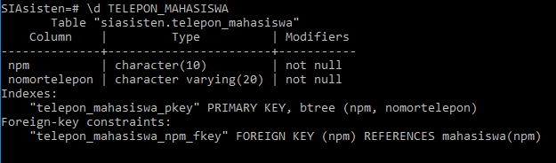

# \d MHS_MENGAMBIL_KELAS_MK

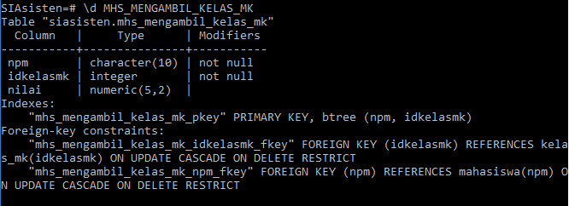

# \d DOSEN_KELAS_MK

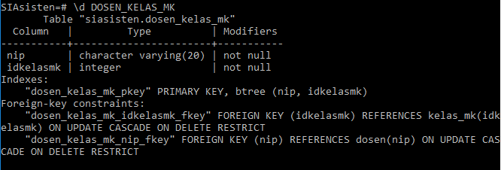

# \d LOWONGAN

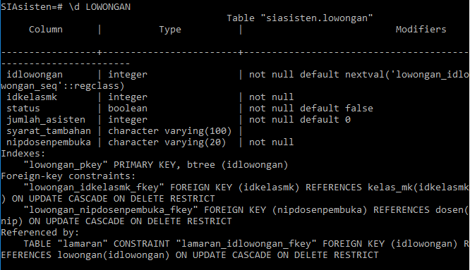

# \d STATUS_LAMARAN

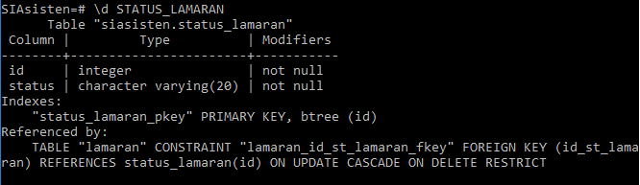

# \d LAMARAN

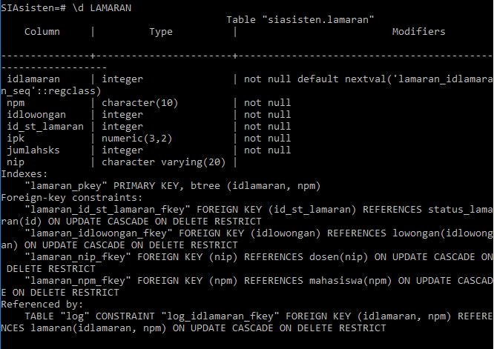

# \d STATUS_LOG

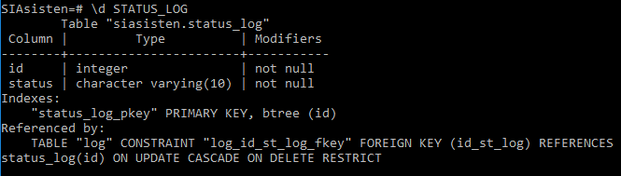

# \d KATEGORI_LOG

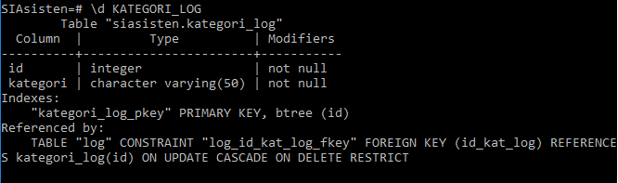

# \d LOG

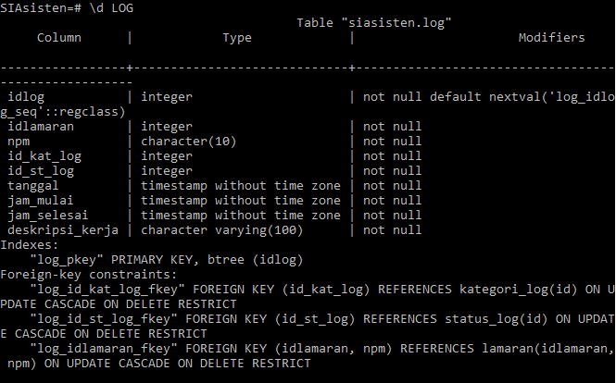

INSERT MATA_KULIAH

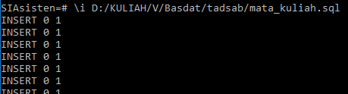

# SELECT * FROM MATA_KULIAH;

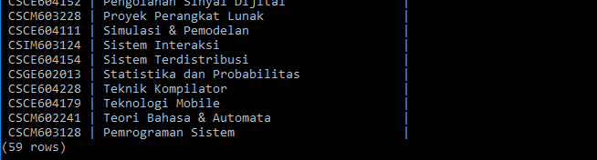

INSERT TERM

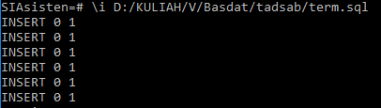

# SELECT * FROM TERM;

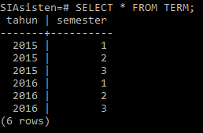

INSERT KELAS_MK

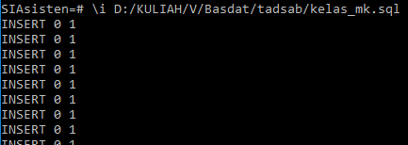

# SELECT * FROM KELAS_MK;

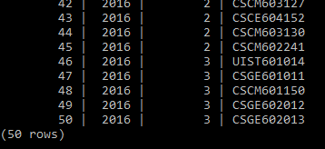

INSERT DOSEN

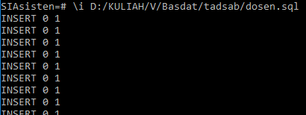

# SELECT * FROM DOSEN;

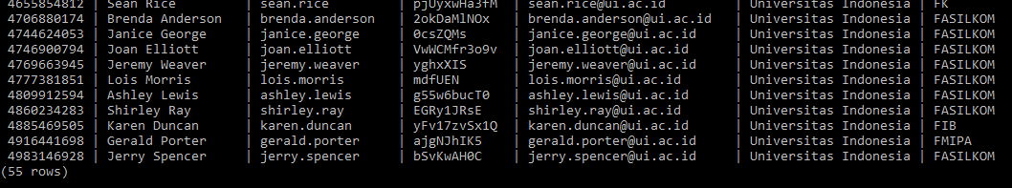

INSERT MAHASISWA

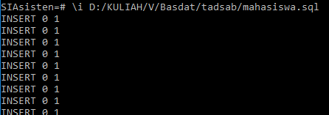

# SELECT * FROM MAHASISWA;

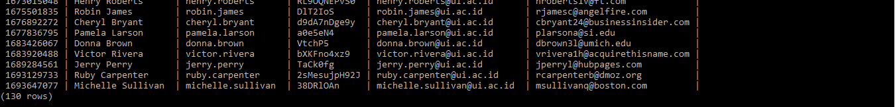

INSERT TELEPON_MAHASISWA

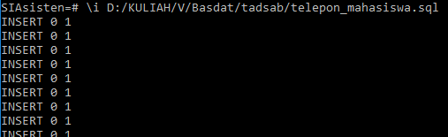

# SELECT * FROM TELEPON_MAHASISWA;

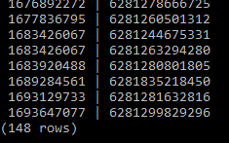

INSERT MHS_MENGAMBIL_KELAS_MK

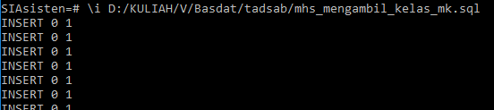

# SELECT * FROM MHS_MENGAMBIL_KELAS_MK;

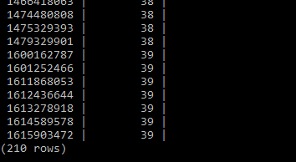

INSERT DOSEN_KELAS_MK

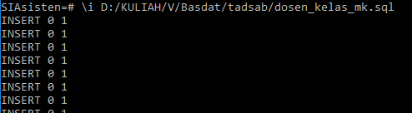

# SELECT * FROM DOSEN_KELAS_MK;

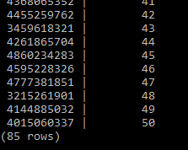

INSERT LOWONGAN

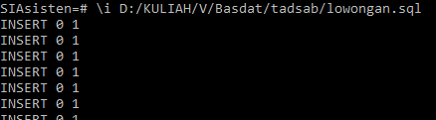

# SELECT * FROM LOWONGAN;

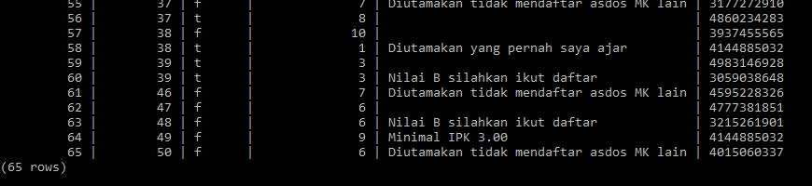

INSERT STATUS_LAMARAN

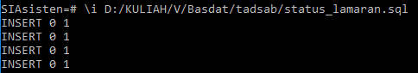

# SELECT * FROM STATUS_LAMARAN;

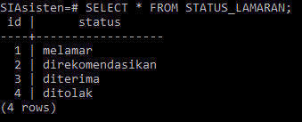

INSERT LAMARAN

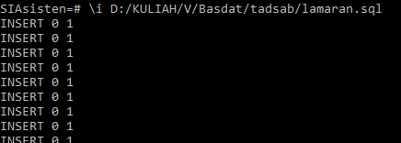

# SELECT * FROM LAMARAN;

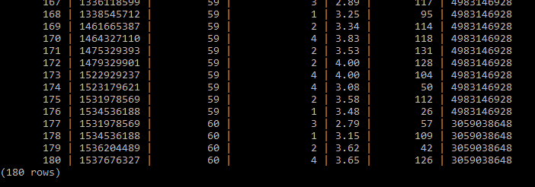

INSERT STATUS_LOG

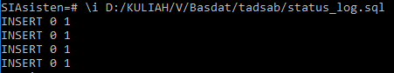

# SELECT * FROM STATUS_LOG;

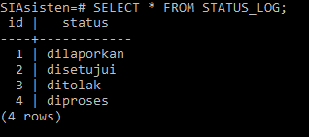

INSERT KATEGORI_LOG

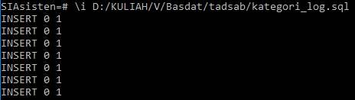

# SELECT * FROM KATEGORI_LOG;

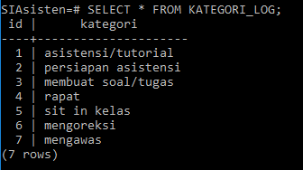

INSERT LOG

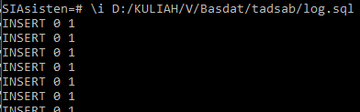

# SELECT * FROM LOG;

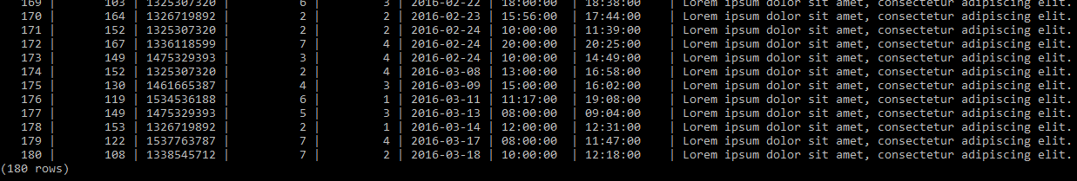

Kontribusi setiap anggota kelompok:

|  |  |  |  |
| --- | --- | --- | --- |
| NPM | Nama | Deskripsi Tugas | Kontribusi |
| 1406565764 | Meitya Dianti | Men-generate data acak (6 table) dan membuat script insert table (14 table) | 33.33333% |
| 1406566924 | Imanda Minara Putri | Men-generate data acak (8 table) dan membuat script insert table (14 table) | 33.33333% |
| 1406572385 | Firda Dhea Sauzan | - | 0% |
| 1406577064 | Muthia Nabila | Membuat script DDL untuk create schema, table, domain dan membuat script insert table (14 table) | 33.33333% |